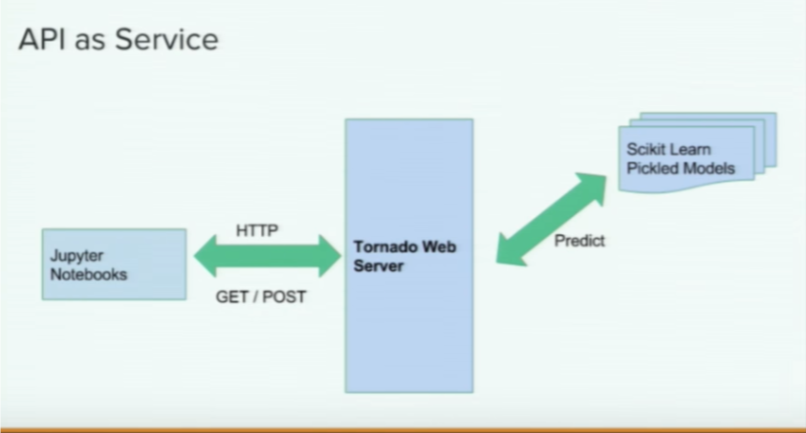

1. Pip install cookiecutter

# Cookiecutter allows us to pull templates and use templates into creating our own app

1. Change directory into Django-tutorial
2. Open shell and go into the same Django_tutorial directory
3. From terminal window navigate to

cookiecutter <https://github.com/sampathweb/cc-iris-api>

1. It will ask you couple of questions

Just use the default by pressing enter

Or if you wish to change them feel free to change them

1. Change directory to iris-api
2. Now we will create a virtual environment

Python env/create_env.py

Source activate env/venv #windows : activate env/venv

# if the process goes fine you will see a (env/venv) in your terminal

1. Python env/install_packages.py